Author: Technical team Version: 2.1.3 Module: Pathology Date: 31-03-2022

**TERTIARY HMIS BUSINESS REQUIREMENT DOCUMENT**





**Prepared y:**

Technical Team

Contents

**1** **Introduction of PATHOLOGY LAB** 2

**2** **process flow DIAGRAM & explanation** 3

**3** 4

**3.1** **Pathology Lab User Interfaces:** 4

**3.1.1** **Pending Patient List:** 4

**3.1.2** **Add Patient:** 8

**3.1.3** **Scheduled Patient:** 12

**3.1.4** **Rejected Patient List:** 14

**3.1.5** **Investigation Registration Slip:** 16

**3.1.6** **Sample Collection:** 17

**3.1.7** **Sample Collection Slip:** 20

**3.1.8** **Sample Collection Scheduled Patient:** 21

**3.1.9** **Sample Receiving :** 24

**3.1.10** **Sample Receiving :** 26

**3.1.11** **Investigation Perform:** 29

**3.1.12** **Investigation Perform:** 32

**3.1.13** **Verify Results:** 35

**3.1.14** **Reports:** 38

# **Introduction of PATHOLOGY LAB**

Pathology services are provided to patients from OPD, Emergency and Indoor. For all the cases, the concerned doctor from any of aforementioned units refers the patient to the Pathology department for required investigations. OPD and ER patients are prescribed Pathology investigations on OPD or ER patient slip. Pathology services for detained patients in ER are free of cost, other OPD and ER patients visit office of Parchi Clerk to pay test fee, or visits the office of authorized person for a waiver of fee, and then visit Pathology department for required investigations.

Diagnostic services for all admitted patients are free of cost. Admitted patients are issued a Referral Slip from Indoor unit. Patients then visit Pathology department with this slip for investigations

# **process flow DIAGRAM & explanation**

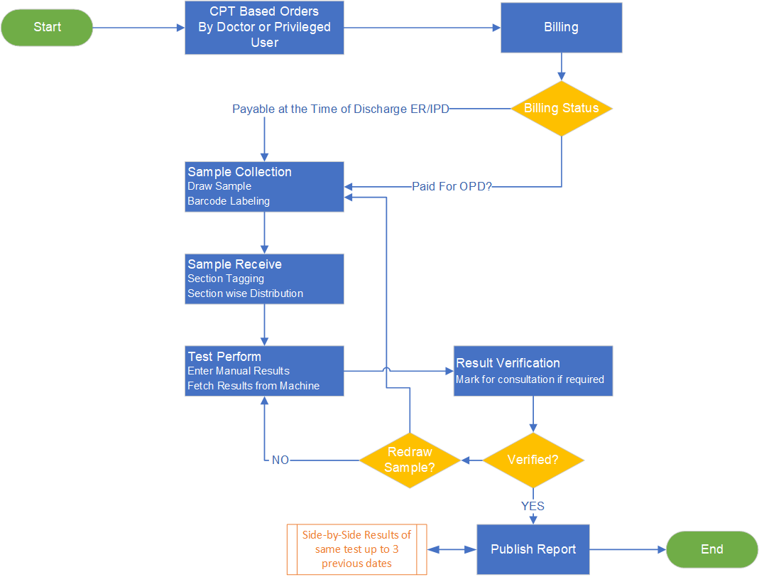

# 

## **Pathology Lab User Interfaces:**

### **Pathology Investigation Definition:**

This page is to define or add pathology investigation for concerned departments

**Event Specification:**

By default user will land on **- Investigation Definition** upon logon.

**Usecase Steps:**

1. System will generate **Investigation ID** in this field
2. User will enter **Investigation Name** in this field
3. User will enter **Abbreviation** **or Short Name** for Investigation in this field
4. User will select **Section** in this dropdown
5. User will enter **Sample Type** in this field
6. User will enter **No. of Procedures** in this field (means how many specifics attached with it )
7. User will enter **Reporting Case** in this field (means if more than one case will render on report regarding this investigation)
8. System will generate **Transaction Date** in this field
9. User will select **Department** in this dropdown as ER , IPD and OPD
10. User will enter **Price** in this field
11. User will enter **Cost** in this field
12. User will select **Billing Status** in this drop down as Invoiced or Open
13. User will click **Plus** to add aforementioned information in editable view
14. User can select **Section Order** Print to map with this investigation
15. User can select **Clinical Report** Print to map with this investigation
16. User can select **Open Price** to map with this investigation in order to keep price open for ER & IPD
17. User can select **Inpatient Invoice** to generate Billing for each IPD admitted order to map with this investigation
18. User can select **Dr. Required** to map with this investigation to appear in Verification Section
19. User can select **Consultant Required** to map with this investigation to appear in Verification Section
20. User can select **Assessment Required** to map with this investigation to appear in Verification Section
21. User will click **Save** button to store aforementioned information in database

**Section Header**

|  |  |  |  |  |  |
| --- | --- | --- | --- | --- | --- |
| Sr. No. | Field Name | Type | Values | Detail | Validation |
|  | Investigation ID | Numeric | 13 Digit | System will generate 13 digit number to map it with Investigation Name | Mandatory |
|  | Investigation Name | Text field | 100 Character | User can enter up to 100 character in it | Mandatory |
|  | Abbreviation | Text field | 10 Character | User can enter up to 10 character in it | Mandatory |
|  | Section | Text field | 50 Character | User can enter up to 50 character in it | Mandatory |
|  | Sample Type | Text field | 50 Character | User can enter up to 50 character in it | Mandatory |
|  | No. of Procedure | Numeric | 10 Digit | User can enter up to 10 digit in it | Mandatory |
|  | Reporting Case | Numeric | 10 Digit | User can enter up to 10 digit in it | Mandatory |
|  | Transaction Date | Date | System Date & Time | System will retrieve time and date in it | Mandatory |
|  | Department | Dropdown | * ER * OPD * IPD | User selection | Mandatory |
|  | Price | Numeric | 10 Digit | User can enter up to 10 digit in it | Mandatory |
|  | Cost | Numeric | 10 Digit | User can enter up to 10 digit in it | Mandatory |
|  | Billing Status | Dropdown | * Invoiced * Open * Non Invoiced | User will select one of the value for each entry | Mandatory |
|  | Plus | Button | Plus Icon | User will click this button to add selected information in editable list view | Mandatory |

* **System will not allow duplicate entries**

**Columned List**

|  |  |  |  |  |  |
| --- | --- | --- | --- | --- | --- |
| Sr. No. | Field Name | Type | Values | Detail | Validation |
|  | Investigation ID | Read-Only |  | Retrieve values from database saved against it | Mandatory |
|  | Investigation Name | Read-Only |  | Retrieve values from database saved against it | Mandatory |
|  | Abbreviation | Read-Only |  | Retrieve values from database saved against it | Mandatory |
|  | Section | Read-Only |  | Retrieve values from database saved against it | Mandatory |
|  | Sample Type | Read-Only |  | Retrieve values from database saved against it | Mandatory |
|  | No. of Procedure | Read-Only |  | Retrieve values from database saved against it | Mandatory |
|  | Reporting Case | Read-Only |  | Retrieve values from database saved against it | Mandatory |
|  | Transaction Date | Read-Only |  | Retrieve values from database saved against it | Mandatory |
|  | Department | Read-Only |  | Retrieve values from database saved against it | Mandatory |
|  | Price | Read-Only |  | Retrieve values from database saved against it | Mandatory |
|  | Cost | Read-Only |  | Retrieve values from database saved against it | Mandatory |
|  | Billing Status | Read-Only |  | Retrieve values from database saved against it | Mandatory |
|  | Plus | Read-Only |  | Retrieve values from database saved against it | Mandatory |

**Section Checkbox**

|  |  |  |  |  |  |
| --- | --- | --- | --- | --- | --- |
| Sr. No. | Label Name | Type | Values | Detail | Validation |
|  | Section Order Print | Checkbox |  | User can select to assign printable section order to this investigation | Mandatory |
|  | Clinical Report Print | Checkbox |  | User can select to assign clinical report print to this investigation | Mandatory |
|  | Open Price | Checkbox |  | User can select this to assign open price tag to this investigation | Mandatory |
|  | Inpatient Auto Invoice | Checkbox |  | User can select this to assign inpatient billing for this investigation | Mandatory |
|  | Dr Required | Checkbox |  | User can select this assign dr remarks in verification section | Mandatory |
|  | Consultant Required | Checkbox |  | User can select this assign consultant remarks in verification section | Mandatory |
|  | Assessment Required | Checkbox |  | User can select this assign to print on report for physical examination is required | Mandatory |
|  | Save | Button |  | To Save selected information in database | Mandatory |

1 - Investigation Definition

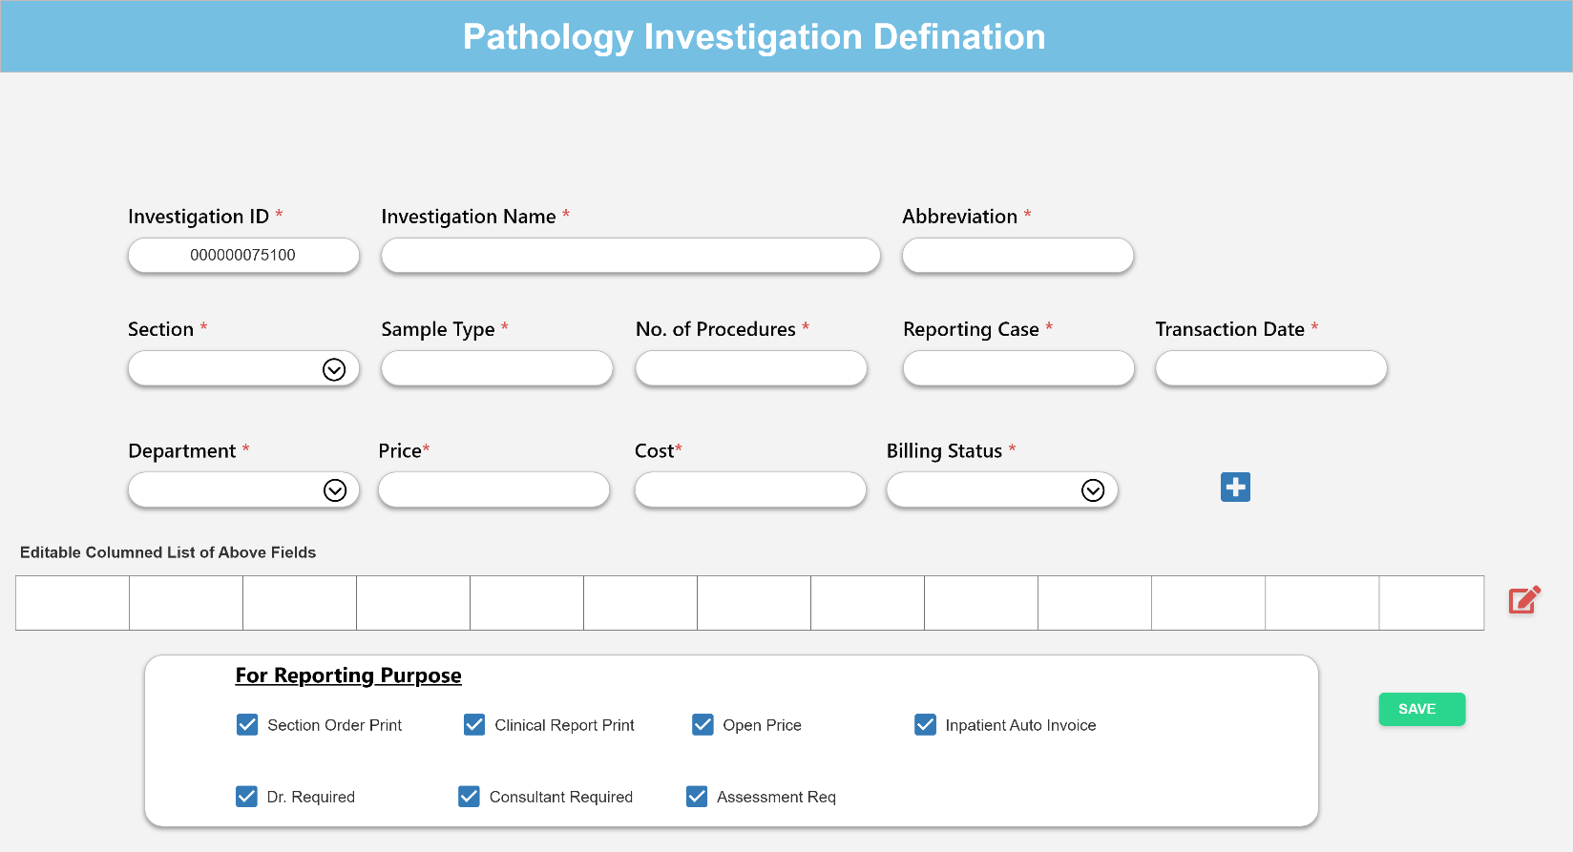

### **Investigation Parameter Definition:**

This page is to define or add pathology investigation parameter for concerned Investigation

**Event Specification:**

By default user will click on **- Parameter Definition** to define/add parameter.

**Usecase Steps:**

1. System will generate **Parameter ID** in this field
2. User will enter **Parameter Name** in this field
3. User will enter **Normal Ranges** of parameters in this field
4. User will enter **Units** of parameters in this field
5. User will select **Gender** according to selected parameter values
6. User will click **Plus** button to add aforementioned information in editable list view
7. **Each editable row will remain checked via checkbox by default , Further user can unselect it too**
8. To **group** or map above selected information with **Investigation Name** and **Kit Name** .User will Search **Investigation Name** in this field and system will retrieve its ID in **Investigation ID** and **Kit Name** in specified field
9. User will click **Save** button to store all information in database
10. **User will have a view list of stored information with Serial Number**
11. User will have view of checkboxes **“ what to show on Printable Report “**

**Section Header**

|  |  |  |  |  |  |
| --- | --- | --- | --- | --- | --- |
| Sr. No. | Field Name | Type | Values | Detail | Validation |
|  | Parameter ID | Numeric | 4 Digit | System will generate up to 4 digit ID of parameter in this | Mandatory |
|  | Parameter Name | Text Field | 50 Character | User can enter up to 50 Character in this field | Mandatory |
|  | Min Range | Numeric | 50 Character | User can enter up to 50 Character in this field | Mandatory |
|  | Max Range | Numeric | 50 Character | User can enter up to 50 Character in this field | Mandatory |
|  | Unit | String | 10 Character | User can enter up to 10 Character in this field | Mandatory |
|  | Gender | Checkbox | Male  Female  Peads | User will select one value for each entry | Mandatory |
|  | Plus | Button | Plus Icon | User will click this button to add selected information in editable view | Mandatory |
|  | Item List | Edit Icon | Marked Checkbox | Preview of editable list | Mandatory |

**Section Group Item with**

|  |  |  |  |  |  |
| --- | --- | --- | --- | --- | --- |
| Sr. No. | Field Name | Type | Values | Detail | Validation |
|  | Investigation ID | Text Field |  | System will retrieve selected Investigation ID | Mandatory |
|  | Investigation Name | Dropdown | List of Investigation | User will search and select Investigation Name in this dropdown | Mandatory |
|  | Kit Name | Dropdown | List of Kit Name | User will search and select Kit Name in this dropdown | Mandatory |
|  | Save | Button | Save | User will click this button to save information | Mandatory |
|  | Item List | List | List of Values | Preview of list with serial number | Mandatory |

* **System will not allow duplicate entries**

**Section Print on Report**

|  |  |  |  |  |  |
| --- | --- | --- | --- | --- | --- |
| Sr. No. | Label Name | Type | Values | Detail | Validation |
|  | Full Text | Checkbox | Full Name of Investigation | To render full name of investigation on printable report | Mandatory |
|  | Abbreviation | Checkbox | Short Name of Investigation | To render short name of investigation on printable report | Mandatory |
|  | Unit | Checkbox | Unit of Parameter | To render unit of parameter on printable report | Mandatory |
|  | Gender | Checkbox | Male  Female  Peads | To render Gender Based normal ranges name of parameters on printable report | Mandatory |
|  | Min Range | Checkbox | Min Ranges of Parameter | To render normal ranges of parameters on printable report | Mandatory |
|  | Kit Used | Checkbox | Name of Kit | To render name of kit to perform investigation on printable report | Mandatory |

- Parameter Definition

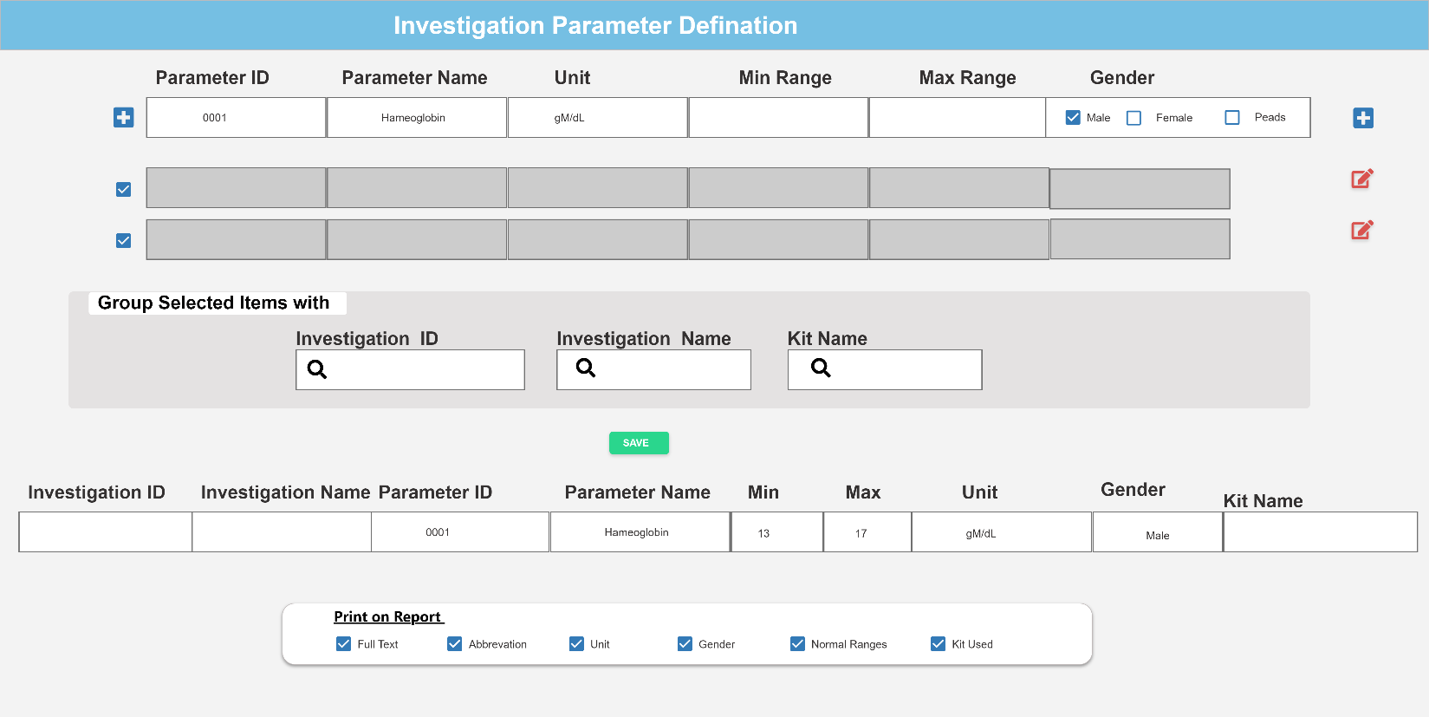

### **Kit Definition:**

This page is too add Kit name and it precision specified for Investigation Performance

**Event Specification:**

By default user will click onto define/add parameter.

**Usecase Steps:**

1. System will generate **Kit ID** in this text field
2. User will enter **Kit Name** in this text field
3. User will enter **Kit Precision** in this text field
4. User will **Date Effective** in this text field
5. User can enter **Remarks** in this text field
6. User will click **Plus** button to add aforementioned information in a editable list view
7. User will click **Save** button to store list view data in database if no changes have been made
8. **User will have preview of saved data in a list view**

* **System will not allow duplicate entries**

**Section Header**

|  |  |  |  |  |  |
| --- | --- | --- | --- | --- | --- |
| Sr. No. | Field Name | Type | Values | Detail | Validation |
|  | Kit ID | Numeric | 4 Digit | System will generate up to 4 digit ID of Kit in this field | Mandatory |
|  | Kit Name | String | 50 Character | User will enter Kit Name up to 50 character in this field | Mandatory |
|  | Min Range | Numeric | 10 Digit | User will enter precision scale up to 10 Digit in this field | Mandatory |
|  | Max Range | Numeric | 10 Digit | User will enter precision scale up to 10 Digit in this field | Mandatory |
|  | Gender | Checkbox | Male  Female  Peads | User can select one of each value for each entry | Mandatory |
|  | Date Effective | Date | System Date and Time | User will select system date and time in this | Mandatory |
|  | Remarks | String | 100 Character | User will enter 100 alphabets in this field | Mandatory |
|  | Plus | Button | Plus Icon | User will click this button to add information in editable view | Mandatory |
|  | Item List | List | Editable list view | System will preview added item in editable list view | Mandatory |
|  | Save | Button | Save | User will enter this button to store added information in database | Mandatory |

**Columned List**

|  |  |  |  |  |  |
| --- | --- | --- | --- | --- | --- |
| Sr. No. | Field Name | Type | Values | Detail | Validation |
|  | Kit ID | Read-Only |  | Retrieve values from database saved against it | Mandatory |
|  | Kit Name | Read-Only |  | Retrieve values from database saved against it | Mandatory |
|  | Precision | Read-Only |  | Retrieve values from database saved against it | Mandatory |
|  | Date Effective | Read-Only |  | Retrieve values from database saved against it | Mandatory |
|  | Remarks | Read-Only |  | Retrieve values from database saved against it | Mandatory |
|  | Item List | Read-Only |  | Retrieve values from database saved against it | Mandatory |

- Kit Definition

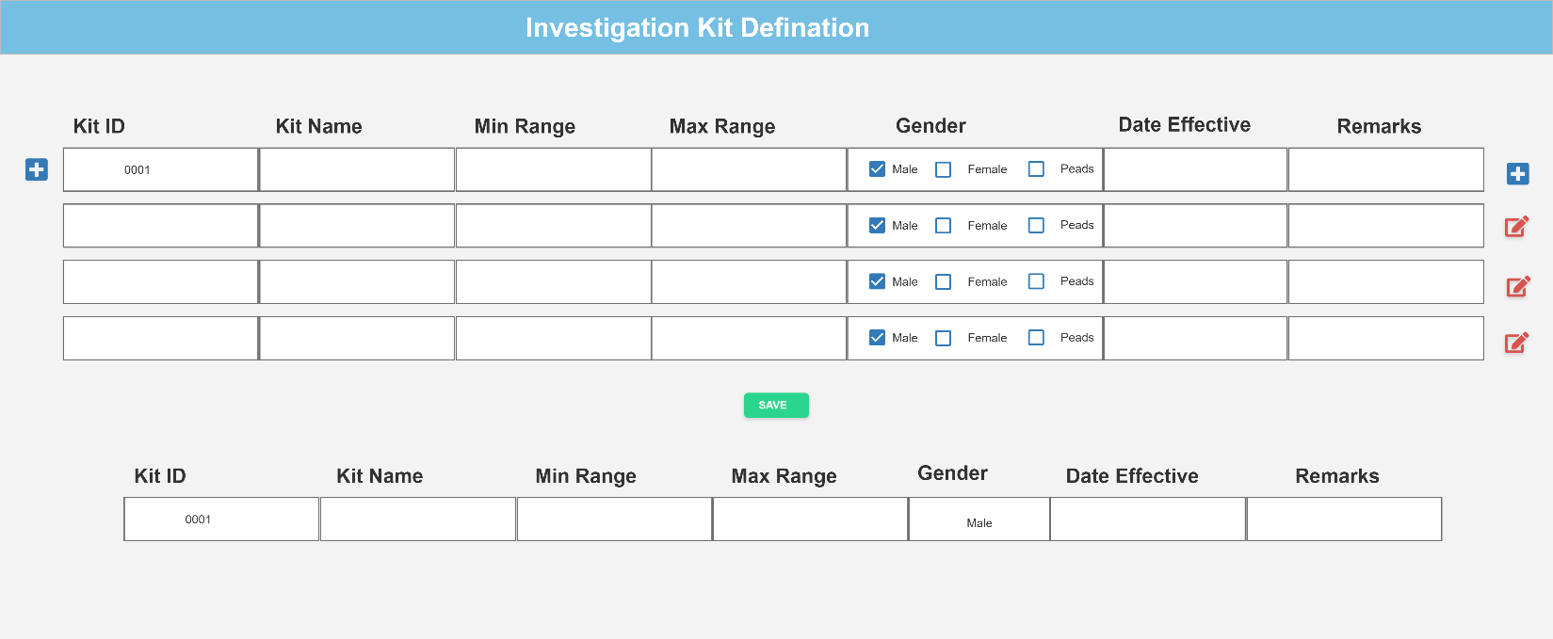

### **CPT Based Order :**

User can add Investigations order manually if received from IPD & Emergency Department and user will have list of manually added patient

**Event Specification:**

By default user will land on **- Pending Patient List** upon logon.

**Usecase Steps:**

1. By default **Current Date** filter will active
2. User can select **From Date** and **To Date** filters to view specific dates patients
3. User will click Search button after selecting specific dates , it will filter out Pending Patient List of that day if available , otherwise banners a message “No data found”
4. User can search patient by following with Like Query

* **MRN , Name , CNIC , Contact**

1. User will have list of patient with following information Columns

* **Serial No , MRN , Name , CNIC, Department , Clinic , Dr Name , Investigation , Order Date , Price**
* **Billing Status : “Free , Paid and Unpaid “**
* **Action : -> Arrow Button , X Button**

1. User can click on **->** to forward patient to sample collection/draw point **OR**
2. User can click on **X** to reject patient and pop up will appears with **Reason** text area
3. User will enter **Reason** in this text area and clicks **Save** button

* **Note: Investigations marked as blue means clicking this will show dependencies/ specifics in detailed pop-up preview**
* **Note: User can see only pending patient list of privileged Sections , More than one section can be privileged to a single User**

**Section Header**

|  |  |  |  |  |  |
| --- | --- | --- | --- | --- | --- |
| Sr. No. | Field Name | Type | Values | Detail | Validation |
|  | From Date | Date | System Calendar | User can select a day in this field | Mandatory |
|  | To Date | Date | System Calendar | User can select a day in this field | Mandatory |
|  | Search | Button | Search | To search all selected information | Mandatory |
|  | Like Search Filter | Text field | String | This search bar will have like query to filter out alphanumeric user inputs in this field | Mandatory |

* **Note: Investigations marked as blue means clicking this will show dependencies/ specifics in detailed pop-up preview**
* **Note: User can see only pending patient list of privileged Sections , More than one section can be privileged to a single User**

**Section Body (Columned List)**

|  |  |  |  |  |  |
| --- | --- | --- | --- | --- | --- |
| Sr. No. | Label Name | Type | Values | Detail | Validation |
|  | Sr# | Read-Only | System generated numeric values | Lists patient in ascending order as per serial number | Mandatory |
|  | MRN | Read-Only |  | Retrieve values from database saved against it | Mandatory |
|  | Name | Read-Only |  | Retrieve values from database saved against it | Mandatory |
|  | CNIC | Read-Only |  | Retrieve values from database saved against it | Mandatory |
|  | Department | Read-Only |  | Retrieve values from database saved against it | Mandatory |
|  | Clinic | Read-Only |  | Retrieve values from database saved against it | Mandatory |
|  | Dr Name | Read-Only |  | Retrieve values from database saved against it | Mandatory |
|  | Investigation | Read-Only |  | Retrieve values from database saved against it | Mandatory |
|  | Order Date | Read-Only |  | Retrieve values from database saved against it | Mandatory |
|  | Price | Read-Only |  | Retrieve values from database saved against it |  |
|  | Billing Status | Read-Only |  | Retrieve values from database saved against it | Mandatory |
|  | Action | Read-Only | * Forward * Reject | Forward : forwards patient to sample draw counter  Reject : to reject patient by entering reason | Mandatory |

- Pending Patient List

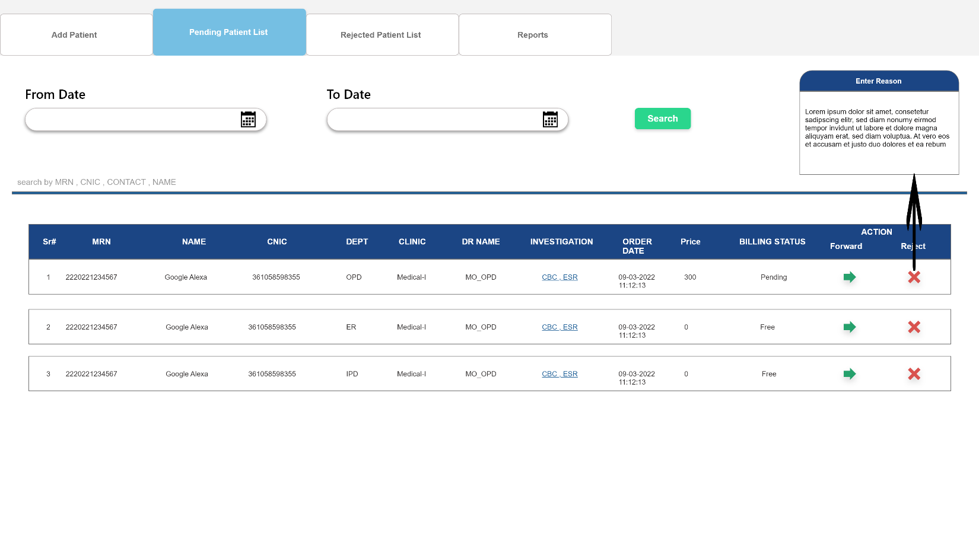

### **CPT Based Order for Privileged User:**

This page is to add patient manually, means Medical Officer has ordered investigations for a specific patient on manual slips.

**Event Specification:**

User will click  **Add Investigation** Tab to register patient’s test written on manual slip

**Usecase Steps:**

1. User will search by **MRN** using this text field
2. User can search patient by **CNIC** using this text field
3. User can search patient by **Name** using this text field
4. User can search patient by **Contact** using this text field
5. User will then click **Search** button to retrieve information according to entered data in specified field
6. System will fetch and previews registered **Patient Demographic Information Header** as shown in figure
7. After verifying patient information , user will **Add Investigation** in this section
8. User will enter **Doctor Name** in this text field
9. User will select **Department** in this dropdown
10. User will select **Clinic** in this dropdown
11. User can select **Ward** in this dropdown incase of IPD department is selected
12. User will select **Investigation Name** in this dropdown
13. User will select **Investigation Specifics** having **Multi Selection and Select All Checkboxes** in this dropdown
14. System will fetch **Investigation Section** in this text field , defined at Configuration Module
15. System will fetch **Price** in this text field , defined at Configuration Module
16. User will click on **Add to List** button to consider selected information in a editable list view
17. User will click on **Save** button to store information in database

* **Note : System will check for duplicate entry , if user is trying to add a patient , who already exists in Pending Patient List**
* **Each dropdown is searchable**
* **Note: User can see only pending patient list of privileged Sections , More than one section can be privileged to a single User**

**Section Header**

|  |  |  |  |  |  |
| --- | --- | --- | --- | --- | --- |
| Sr. No. | Field Name | Type | Values | Detail | Validation |
|  | Search by MRN | Numeric | 7 Digit | User can search patient by entering 7 digit of patient medical record number excluded of hospital_id and year | Mandatory |
|  | Search by CNIC | Numeric | 13 Digit | User will enter 13 digit CNIC to search patient | Mandatory |
|  | Search by Name | Text field | 50 Character | User can enter up to 50 character of to search patient by name | Mandatory |
|  | Search by Contact | Numeric | 11 Digit | User will enter 11 digit contact to search patient | Mandatory |
|  | Search | Button | Search | User will click this button to retrieve information from database | Mandatory |
|  | Patient Information Header | Labels | **Name , MRN , CNIC , Contact , Age , Visit , Date** | Display retrieved information from database according to mentioned labels | Mandatory |

**Section Body (Add Investigation)**

|  |  |  |  |  |  |
| --- | --- | --- | --- | --- | --- |
| Sr. No. | Field Name | Type | Values | Detail | Validation |
|  | Doctor Name | Text field | 50 character | User can enter 50 alphabets in this field | Mandatory |
|  | Department | Dropdown | OPD  IPD  ER | Retrieve and display list of department User can select single for each entry | Mandatory |
|  | Clinic | Dropdown | List of Clinics | Retrieve and display clinics. User will select single value for each entry | Mandatory |
|  | Ward | Dropdown | List of Ward | Retrieve and display ward in case of IPD is selected User will select single value for each entry | Mandatory |
|  | Investigation Name | Dropdown | List of Investigations | Retrieve and display investigations User will select single value for each entry | Mandatory |
|  | Investigation Specifics | Dropdown | List of Investigations Specifics | Retrieve and display investigation specifics according to investigation selection User can select multiple option for each entry or checks Select All option | Mandatory |
|  | Investigation Category | Dropdown | List of Investigation Category | System will retrieve category according to selected investigation | Mandatory |
|  | Price |  | 4 Digit | System will retrieve Price according to selected investigation |  |
|  | Add to List | Button | Add to List | consider data in editable list view | Mandatory |
|  | Save | Button | Save | User will click this button to store information in database | Mandatory |

**Section Footer (Columned List)**

|  |  |  |  |  |  |
| --- | --- | --- | --- | --- | --- |
| Sr. No. | Label Name | Type | Values | Detail | Validation |
|  | Sr# | Read-Only | System generated numeric values | Lists patient in ascending order as per serial number | Mandatory |
|  | Dr Name | Read-Only |  | Retrieve values from database saved against it | Mandatory |
|  | Department | Read-Only |  | Retrieve values from database saved against it | Mandatory |
|  | Clinic | Read-Only |  | Retrieve values from database saved against it | Mandatory |
|  | Ward | Read-Only |  | Retrieve values from database saved against it | Mandatory |
|  | Investigation Name | Read-Only |  | Retrieve values from database saved against it | Mandatory |
|  | Investigation Specifics | Read-Only |  | Retrieve values from database saved against it | Mandatory |
|  | Investigation Category | Read-Only |  | Retrieve values from database saved against it | Mandatory |
|  | Price |  | 4 Digit | System will retrieve Price according to selected investigation |  |
|  | Action | Button | **X** | To delete editable listed view | Mandatory |

6- Add Investigation

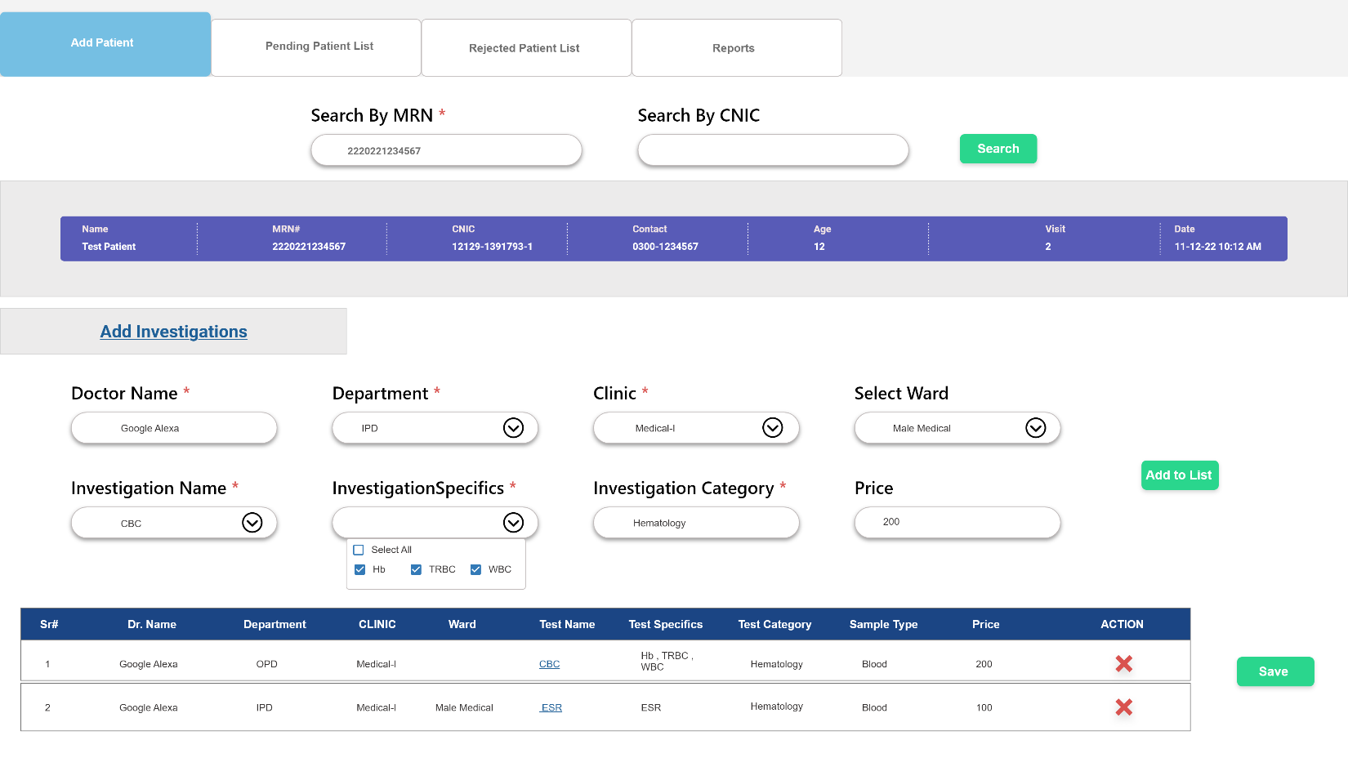

### **Scheduled Patient:**

On this page, User will have list of patient whose sample has drawn and barcode been generated regarding their investigations.

**Event Specification:**

User will click on **- Scheduled Patient**. Where user will view a patient list

**Usecase Steps:**

1. By default **Current Date** filter will active
2. User can select **From Date** and **To Date** filters to view specific dates patients
3. User will click Search button after selecting specific dates , it will filter out Pending Patient List of that day if available , otherwise banners a message “No data found”
4. User can search patient by following with Like Query

* **MRN , Name , CNIC , Contact**

1. User will have list of patient with following information Columns

* **Serial No , MRN , Name , CNIC, Department , Clinic , Dr Name , Investigation , Order Date , Sample Drawn Date , Sample No.**
* **Billing Status : “Free , Paid and Unpaid “**

1. **Status : “Forwarded to Sample Collection” User Button will have this button turned green**

**Section Header**

|  |  |  |  |  |  |
| --- | --- | --- | --- | --- | --- |
| Sr. No. | Field Name | Type | Values | Detail | Validation |
|  | From Date | Date | System Calendar | User can select a day in this field | Mandatory |
|  | To Date | Date | System Calendar | User can select a day in this field | Mandatory |
|  | Search | Button | Search | To search all selected information | Mandatory |
|  | Like Search Filter | Text field | String | This search bar will have like query to filter out alphanumeric user inputs in this field | Mandatory |

* **Note: Investigations marked as blue means clicking this will show dependencies/ specifics in detailed pop-up preview**

**Section Body (Columned List)**

|  |  |  |  |  |  |
| --- | --- | --- | --- | --- | --- |
| Sr. No. | Label Name | Type | Values | Detail | Validation |
|  | Sr# | Read-Only | System generated numeric values | Lists patient in ascending order as per serial number | Mandatory |
|  | MRN | Read-Only |  | Retrieve values from database saved against it | Mandatory |
|  | Name | Read-Only |  | Retrieve values from database saved against it | Mandatory |
|  | CNIC | Read-Only |  | Retrieve values from database saved against it | Mandatory |
|  | Department | Read-Only |  | Retrieve values from database saved against it | Mandatory |
|  | Clinic | Read-Only |  | Retrieve values from database saved against it | Mandatory |
|  | Dr Name | Read-Only |  | Retrieve values from database saved against it | Mandatory |
|  | Investigation | Read-Only |  | Retrieve values from database saved against it | Mandatory |
|  | Order Date | Read-Only |  | Retrieve values from database saved against it | Mandatory |
|  | Sample Drawn Date | Read-Only |  | Retrieve values from database saved against it | Mandatory |
|  | Billing Status | Read-Only |  | Retrieve values from database saved against it | Mandatory |
|  | Status | Button | Forwarded to Sample Collection | Status button to knew where patient is currently landing | Mandatory |

7 - Scheduled Patient

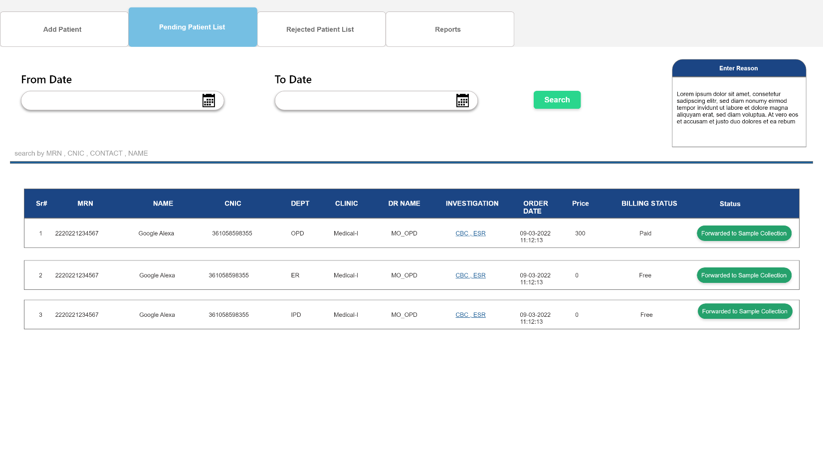

### **Rejected Patient List:**

Patient who were initially appearing in **Pending Patient** **List**, somehow rejected by user with written reason will appear on this page as listed View.

**Event Specification:**

User will click on **- Rejected Patient List** Tab to view rejected patient list

**Usecase Steps:**

1. By default **Current Date** filter will active
2. User can select **From Date** and **To Date** filters to view specific dates patients
3. User will click Search button after selecting specific dates , it will filter out Pending Patient List of that day if available , otherwise banners a message “No data found”
4. User can search patient by following with Like Query

* **MRN , Name , CNIC , Contact**

1. User will have list of patient with following information Columns

* **Serial No , MRN , Name , CNIC, Department , Clinic , Dr Name , Investigation , Order Date , Rejected By , Reason**

**Section Body (Columned List)**

|  |  |  |  |  |  |
| --- | --- | --- | --- | --- | --- |
| Sr. No. | Label Name | Type | Values | Detail | Validation |
|  | Sr# | Read-Only | System generated numeric values | Lists patient in ascending order as per serial number | Mandatory |
|  | MRN | Read-Only |  | Retrieve values from database saved against it | Mandatory |
|  | Name | Read-Only |  | Retrieve values from database saved against it | Mandatory |
|  | CNIC | Read-Only |  | Retrieve values from database saved against it | Mandatory |
|  | Department | Read-Only |  | Retrieve values from database saved against it | Mandatory |
|  | Clinic | Read-Only |  | Retrieve values from database saved against it | Mandatory |
|  | Dr Name | Read-Only |  | Retrieve values from database saved against it | Mandatory |
|  | Investigation | Read-Only |  | Retrieve values from database saved against it | Mandatory |
|  | Order Date | Read-Only |  | Retrieve values from database saved against it | Mandatory |
|  | Rejected By | Read-Only |  | Retrieve values from database saved against it | Mandatory |
|  | Reason | Read-Only |  | Retrieve values from database saved against it | Mandatory |

- Rejected Patient List

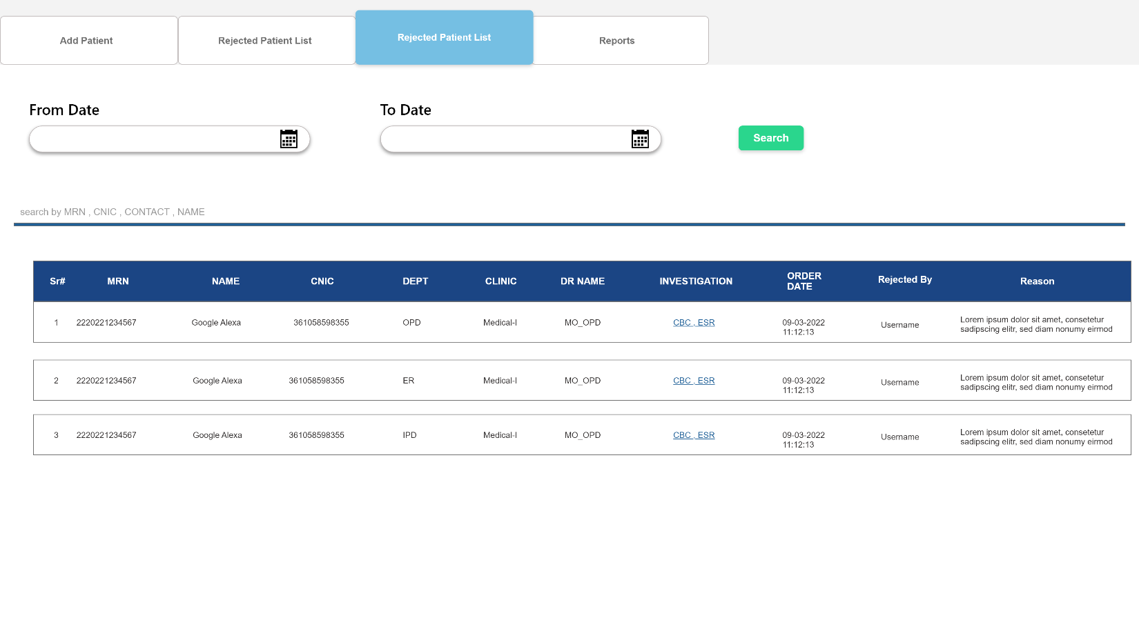

### **Investigation Registration Slip:**

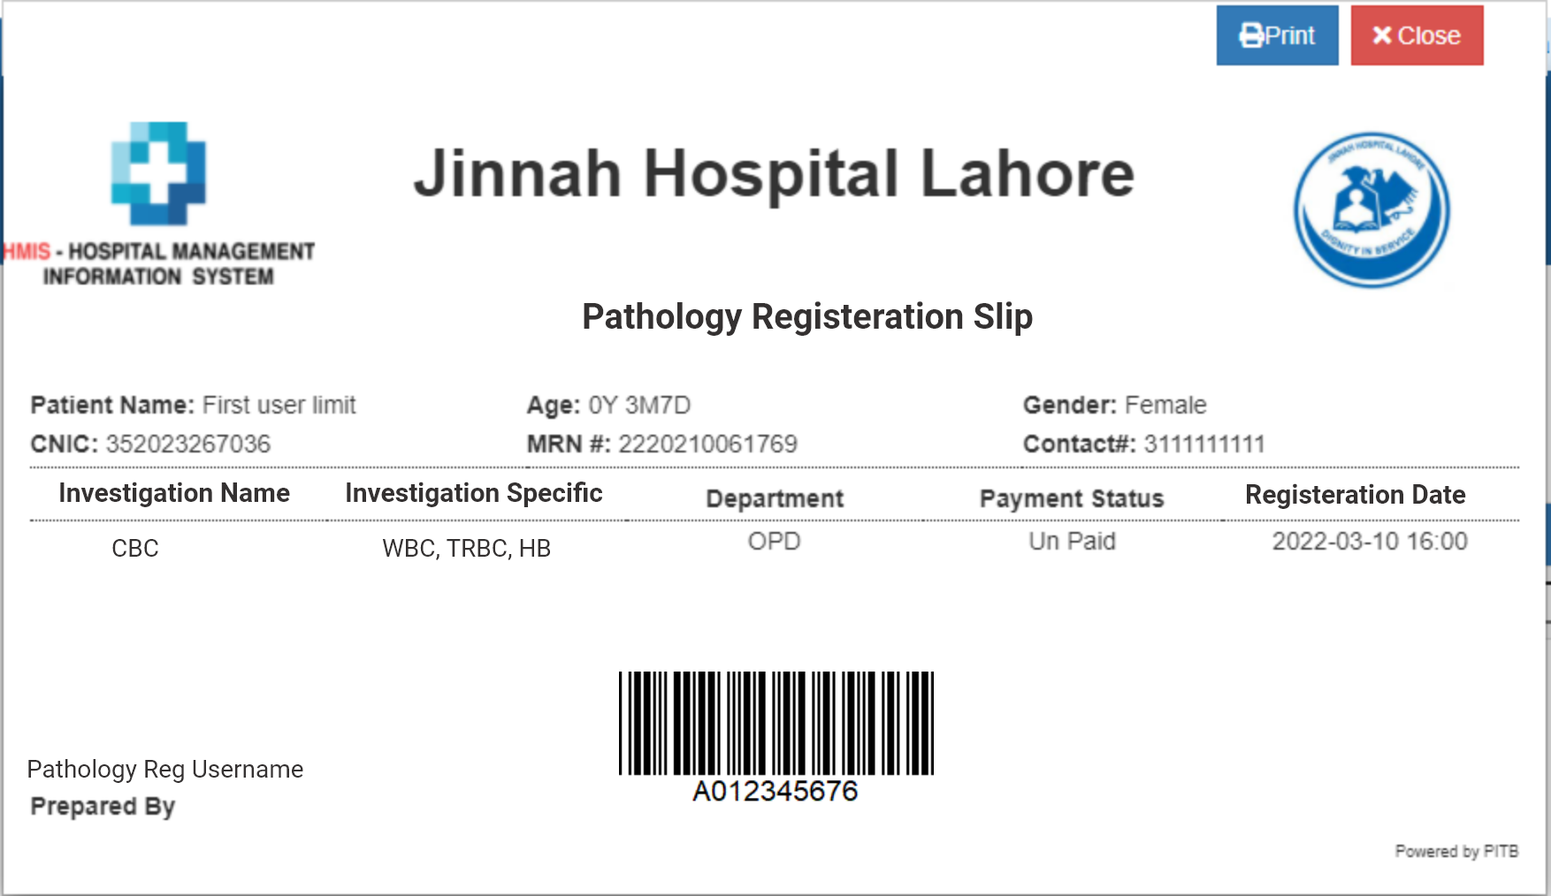

### **Sample Collection:**

On this page, User will have list of patient whose Investigations Medical Officer has ordered and Investigations ordered manually added at Registration

**Event Specification:**

By default user will land on **- Sample Collection** Pending Listupon logon

**Usecase Steps:**

1. By default **Current Date** filter will active
2. User can select **From Date** and **To Date** filters to view specific dates patients
3. User will click Search button after selecting specific dates , it will filter out Pending Patient List of that day if available , otherwise banners a message “No data found”
4. User can search patient by following with Like Query

* **MRN , Name , CNIC , Contact**

1. User will have list of patient with following information Columns

* **Serial No , MRN , Name , CNIC, Department , Clinic , Dr Name , Investigation , Order Date**
* **Billing Status : “Free , Paid and Unpaid “**
* **User will Select Reporting Desk in this dropdown , it will print on report to inform patient from where to collect Report**
* **Action : Sample Drawn Checkbox , Generate Barcode Button , X Button**

1. **User will click on this checkbox if sample has been drawn in Lab Vile and clicks Generate Barcode Button to generate printable format to label Vile**
2. User can click on **X** to reject patient and pop up will appears with **Reason** text area
3. User will enter **Reason** in this text area and clicks **Save** button

* **Note : Sample Drawn checkbox and Generate Barcode button will remain active for following cases otherwise non-active**
* **Patient referred from Emergency & IPD Department and has Billing Status = Free**
* **Patient referred from OPD Department and has Billing Status = Paid**

**Section Header**

|  |  |  |  |  |  |
| --- | --- | --- | --- | --- | --- |
| Sr. No. | Field Name | Type | Values | Detail | Validation |
|  | From Date | Date | System Calendar | User can select a day in this field | Mandatory |
|  | To Date | Date | System Calendar | User can select a day in this field | Mandatory |
|  | Search | Button | Search | To search all selected information | Mandatory |
|  | Like Search Filter | Text field | String | This search bar will have like query to filter out alphanumeric user inputs in this field | Mandatory |

* **Note: Investigations marked as blue means clicking this will show dependencies/ specifics in detailed pop-up preview**
* **Note : Save time and date when Sample Drawn Checkbox is clicked to populate time date in Scheduled Patient**

**Section Body (Columned List)**

|  |  |  |  |  |  |
| --- | --- | --- | --- | --- | --- |
| Sr. No. | Label Name | Type | Values | Detail | Validation |
|  | Sr# | Read-Only | System generated numeric values | Lists patient in ascending order as per serial number | Mandatory |
|  | MRN | Read-Only |  | Retrieve values from database saved against it | Mandatory |
|  | Name | Read-Only |  | Retrieve values from database saved against it | Mandatory |
|  | CNIC | Read-Only |  | Retrieve values from database saved against it | Mandatory |
|  | Department | Read-Only |  | Retrieve values from database saved against it | Mandatory |
|  | Clinic | Read-Only |  | Retrieve values from database saved against it | Mandatory |
|  | Dr Name | Read-Only |  | Retrieve values from database saved against it | Mandatory |
|  | Investigation | Read-Only |  | Retrieve values from database saved against it | Mandatory |
|  | Order Date | Read-Only |  | Retrieve values from database saved against it | Mandatory |
|  | Billing Status | Read-Only |  | Retrieve values from database saved against it | Mandatory |
|  | Reporting Desk | Dropdown | Pathology Reporting Desk | User will select value and it will print on Report | Mandatory |
|  | Action | Checkbox | Sample Drawn | User will check this button if user has drawn the sample in vile  Note time and date when clicked | Mandatory |
|  | Button | System Generated Generate Barcode | System User will click this button in order generate and printable barcode to label the sample drawn vile | Mandatory |
|  | X | X | User will click this button in order to reject patient by entering a reason of rejection | Mandatory |

- Sample Collection

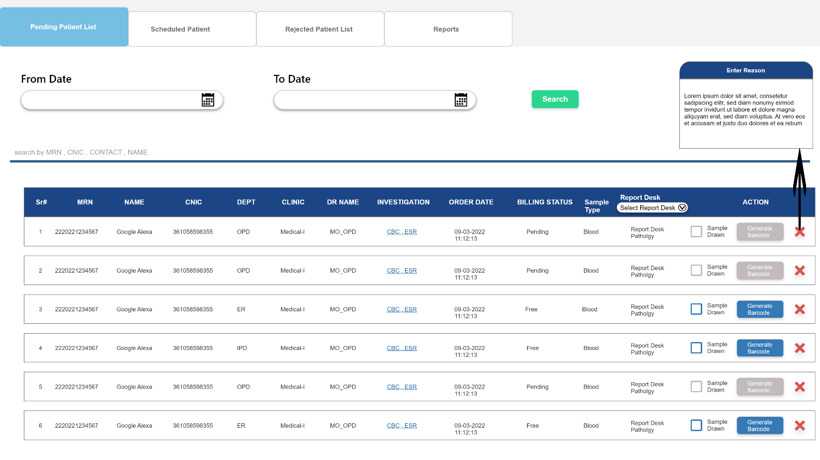

### **Sample Collection Slip:**

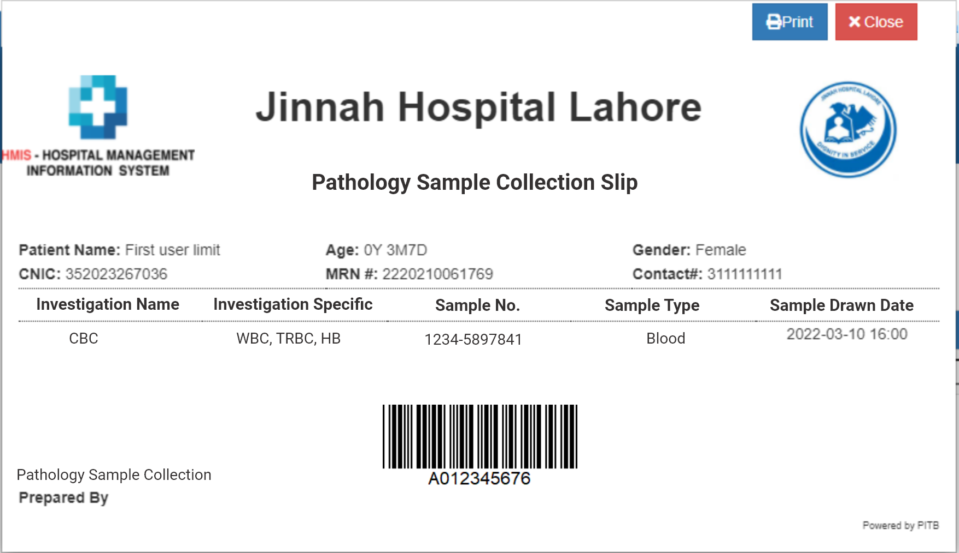

### **Sample Collected :**

On this page, User will have list of patient whose sample has drawn and barcode been generated regarding their investigations.

**Event Specification:**

User will click on **- Scheduled Patient** . Where user will view a patient list

**Usecase Steps:**

1. By default **Current Date** filter will active
2. User can select **From Date** and **To Date** filters to view specific dates patients
3. User will click Search button after selecting specific dates , it will filter out Pending Patient List of that day if available , otherwise banners a message “No data found”
4. User can search patient by following with Like Query

* **MRN , Name , CNIC , Contact**

1. User will have list of patient with following information Columns

* **Serial No , MRN , Name , CNIC, Department , Clinic , Dr Name , Investigation , Order Date , Sample Drawn Date , Sample No.**
* **Billing Status : “Free , Paid and Unpaid “**
* **Status : Sample Drawn Checkbox checked , Generated Barcode Button**
* **Sample Reception : Button “Received “ Not Received”**

1. **User will have this checked checkbox for patient’s who sample has been drawn in Lab Vile and Generate Barcode Button will turn green as “Barcode Generated”**
2. **In Sample Reception Label , User will see two button “Green Button ‘Received’ for patient whose sample has been received**
3. **In Sample Reception Label , Orange Button ‘Not Received’ for patient whose sample has not been received**

* **Note : Sample Drawn checkbox will be checked and turns green and Generate Barcode button will turn green and label it as “ Barcode Generated”**

**Section Header**

|  |  |  |  |  |  |
| --- | --- | --- | --- | --- | --- |
| Sr. No. | Field Name | Type | Values | Detail | Validation |
|  | From Date | Date | System Calendar | User can select a day in this field | Mandatory |
|  | To Date | Date | System Calendar | User can select a day in this field | Mandatory |
|  | Search | Button | Search | To search all selected information | Mandatory |
|  | Like Search Filter | Text field | String | This search bar will have like query to filter out alphanumeric user inputs in this field | Mandatory |

* **Note: Investigations marked as blue means clicking this will show dependencies/ specifics in detailed pop-up preview**

**Section Body (Columned List)**

|  |  |  |  |  |  |
| --- | --- | --- | --- | --- | --- |
| Sr. No. | Label Name | Type | Values | Detail | Validation |
|  | Sr# | Read-Only | System generated numeric values | Lists patient in ascending order as per serial number | Mandatory |
|  | MRN | Read-Only |  | Retrieve values from database saved against it | Mandatory |
|  | Name | Read-Only |  | Retrieve values from database saved against it | Mandatory |
|  | CNIC | Read-Only |  | Retrieve values from database saved against it | Mandatory |
|  | Department | Read-Only |  | Retrieve values from database saved against it | Mandatory |
|  | Clinic | Read-Only |  | Retrieve values from database saved against it | Mandatory |
|  | Dr Name | Read-Only |  | Retrieve values from database saved against it | Mandatory |
|  | Investigation | Read-Only |  | Retrieve values from database saved against it | Mandatory |
|  | Order Date | Read-Only |  | Retrieve values from database saved against it | Mandatory |
|  | Sample Drawn Date | Read-Only |  | Retrieve values from database saved against it | Mandatory |
|  | Billing Status | Read-Only |  | Retrieve values from database saved against it | Mandatory |
|  | Status | Checkbox | Sample Drawn | Turn’s Green Checked | Mandatory |
|  | Status | Button | System Generated Generate Barcode | Turn’s Green Barcode Generated | Mandatory |
|  | Sample Reception | Button | * Received * Not Received | Button will turn green for acknowledgement if patient sample vile has received at sample collection.  Else button will remain orange if not received | Mandatory |

- Scheduled Patient

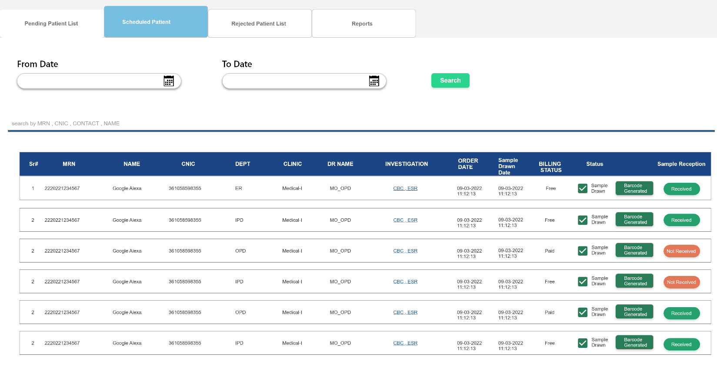

### **Sample Receiving:**

On this page, User will receive and verify collected patient sample forwarded from Lab Sample

**Event Specification:**

By default user will land on **- Lab Reception** Pending Listupon logon.

**Usecase Steps:**

1. By default **Current Date** filter will active
2. User can select **From Date** and **To Date** filters to view specific dates patients
3. User will click **Search** button after selecting specific dates , it will filter out Pending Patient List of that day if available , otherwise banners a message **“No data found”**
4. User can search patient by following with Like Query

* **MRN , Name, CNIC , Contact , Sample No.**

1. User will have list of patient with following information Columns

* **Serial No , MRN , Name , CNIC, Department, Investigation , Order Date ,Sample Drawn Date , Sample No, Investigation Category**
* **Action : Receive Button , Reject Button**

1. User will click **Receive** button to receive patient sample. Received patient will move to **Scheduled Patient List**
2. User will can **Reject** button to reject sample by entering **Reason .**Rejected Patient will move to **Rejected Patient List**
3. **User will click on Create Section Work Order to render pdf report of all received sample section wise , in order to disseminate them section wise**

**Section Header**

|  |  |  |  |  |  |
| --- | --- | --- | --- | --- | --- |
| Sr. No. | Field Name | Type | Values | Detail | Validation |
|  | From Date | Date | System Calendar | User can select a day in this field | Mandatory |
|  | To Date | Date | System Calendar | User can select a day in this field | Mandatory |
|  | Search | Button | Search | To search all selected information | Mandatory |
|  | Like Search Filter | Text field | String | This search bar will have like query to filter out alphanumeric user inputs in this field | Mandatory |

* **Note: Investigations marked as blue means clicking this will show dependencies/ specifics in detailed pop-up preview**

**Section Body (Columned List)**

|  |  |  |  |  |  |
| --- | --- | --- | --- | --- | --- |
| Sr. No. | Label Name | Type | Values | Detail | Validation |
| 1 | Create Section Work Order | Button | Renders pdf report of each sample section wise | User will click this button to create wok order of each section to disseminate sample in each section as tag on sample | Mandatory |
|  | Sr# | Read-Only | System generated numeric values | Lists patient in ascending order as per serial number | Mandatory |
|  | MRN | Read-Only |  | Retrieve values from database saved against it | Mandatory |
|  | Name | Read-Only |  | Retrieve values from database saved against it | Mandatory |
|  | CNIC | Read-Only |  | Retrieve values from database saved against it | Mandatory |
|  | Department | Read-Only |  | Retrieve values from database saved against it | Mandatory |
|  | Investigation | Read-Only |  | Retrieve values from database saved against it | Mandatory |
|  | Order Date | Read-Only |  | Retrieve values from database saved against it | Mandatory |
|  | Sample Drawn Date | Read-Only |  | Retrieve values from database saved against it | Mandatory |
|  | Sample No. | Read-Only |  | Retrieve values from database saved against it | Mandatory |
|  | Action | Button | Receive | User will click this button to receive sample  After receiving patient will move to Scheduled Patient | Mandatory |
|  | Action | Button | Reject | User will click this button to reject patient with reason  After rejection patient will move to Rejected Patient List | Mandatory |

- Lab Reception

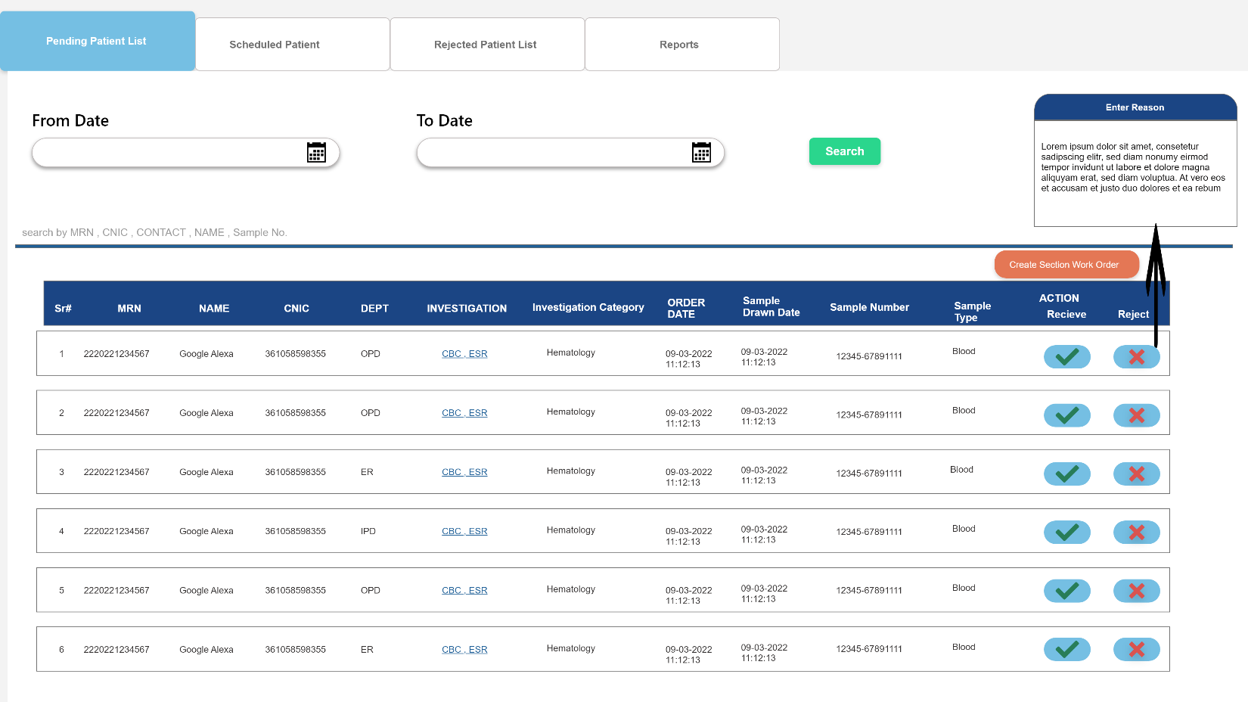

### **Sample Received:**

On this page, User will receive and verify collected patient sample forwarded from Lab Sample

**Event Specification:**

User will click on **- Lab Reception Scheduled Patient** to view patient list whose sample has been received

**Usecase Steps:**

1. By default **Current Date** filter will active
2. User can select **From Date** and **To Date** filters to view specific dates patients
3. User will click **Search** button after selecting specific dates , it will filter out Pending Patient List of that day if available , otherwise banners a message **“No data found”**
4. User can search patient by following with Like Query

* **MRN , Name , CNIC , Contact , Sample No.**

1. User will have list of patient with following information Columns

* **Serial No , MRN , Name , CNIC, Department , Investigation , Order Date ,Sample Drawn Date , Sample No, Investigation Category**
* **Status : Receive Button , Reject Button**

1. User can view Patient list whose sample has received in a status button as **Sample Received**
2. To generate patient work order section wise user can select Checkbox Values
3. **All : To list patient info in printable format of all section**
4. **Hematology , Serology …… : To list patient info in printable format of specific section**

**Section Header**

|  |  |  |  |  |  |
| --- | --- | --- | --- | --- | --- |
| Sr. No. | Field Name | Type | Values | Detail | Validation |
|  | From Date | Date | System Calendar | User can select a day in this field | Mandatory |
|  | To Date | Date | System Calendar | User can select a day in this field | Mandatory |
|  | Search | Button | Search | To search all selected information | Mandatory |
|  | Like Search Filter | Text field | String | This search bar will have like query to filter out alphanumeric user inputs in this field | Mandatory |

**Section Right Pane (Section Work Order)**

|  |  |  |  |  |  |
| --- | --- | --- | --- | --- | --- |
| Sr. No. | Label Name | Type | Values | Detail | Validation |
|  | All | Checkbox |  | Retrieve list of patient from database saved against it render in section report | Mandatory |
|  | Hematology | Checkbox |  | Retrieve list of patient from database saved against it render in section report | Mandatory |
|  | Serology | Checkbox |  | Retrieve list of patient from database saved against it render in section report | Mandatory |
|  | Chemical Pathology | Checkbox |  | Retrieve list of patient from database saved against it render in section report | Mandatory |
|  | Routine Chemistry | Checkbox |  | Retrieve list of patient from database saved against it render in section report | Mandatory |
|  | Histopathology | Checkbox |  | Retrieve list of patient from database saved against it render in section report | Mandatory |

* **Note: Investigations marked as blue means clicking this will show dependencies/ specifics in detailed pop-up preview**

**Section Body (Columned List)**

|  |  |  |  |  |  |
| --- | --- | --- | --- | --- | --- |
| Sr. No. | Label Name | Type | Values | Detail | Validation |
|  | Sr# | Read-Only | System generated numeric values | Lists patient in ascending order as per serial number | Mandatory |
|  | MRN | Read-Only |  | Retrieve values from database saved against it | Mandatory |
|  | Name | Read-Only |  | Retrieve values from database saved against it | Mandatory |
|  | CNIC | Read-Only |  | Retrieve values from database saved against it | Mandatory |
|  | Department | Read-Only |  | Retrieve values from database saved against it | Mandatory |
|  | Investigation | Read-Only |  | Retrieve values from database saved against it | Mandatory |
|  | Order Date | Read-Only |  | Retrieve values from database saved against it | Mandatory |
|  | Sample Drawn Date | Read-Only |  | Retrieve values from database saved against it | Mandatory |
|  | Sample No. | Read-Only |  | Retrieve values from database saved against it | Mandatory |
|  | Status | Button | Received | Display sample received status in form of button value as “Received” | Mandatory |

12 - Lab Reception Scheduled Patient

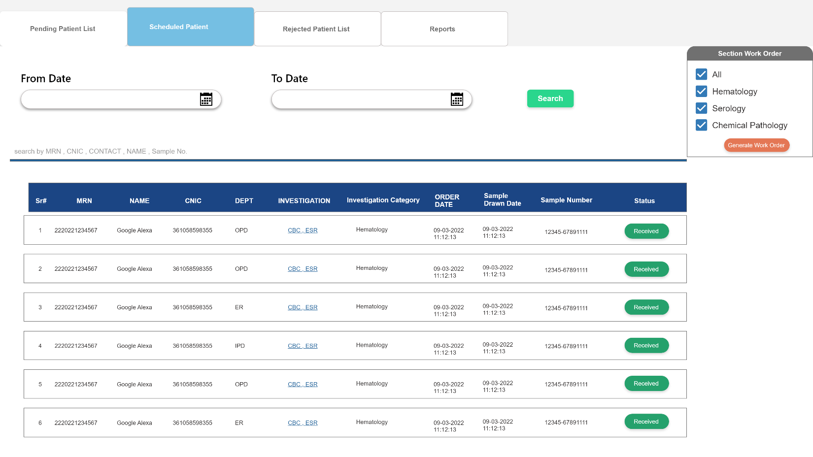

### **Sample Receiving Section Work Order:**

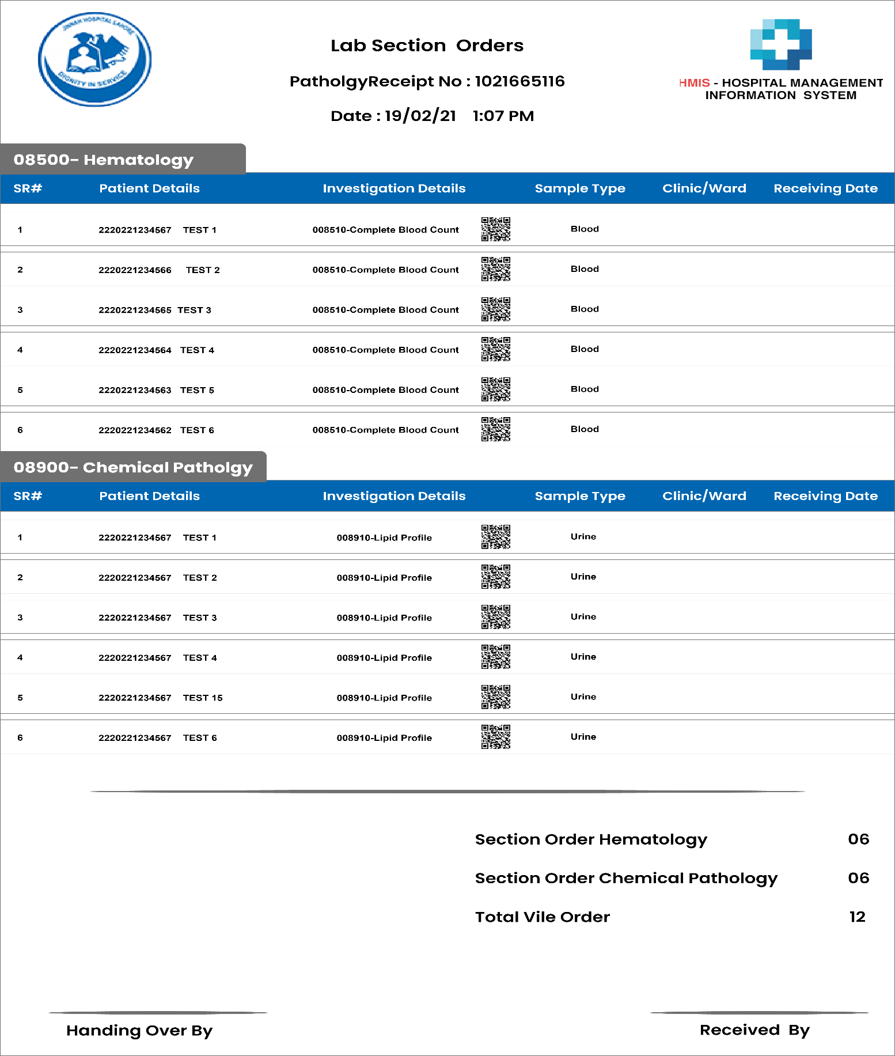

### **Investigation Perform:**

On this page, User will perform test on received samples of patient

**Event Specification:**

User will click on  **- Lab Department Pending List** to add result of performed samples of patients

**Usecase Steps:**

By default **Current Date** filter will active

1. User can select **From Date** and **To Date** filters to view specific dates patients
2. User will click **Search** button after selecting specific dates , it will filter out Pending Patient List of that day if available , otherwise banners a message **“No data found”**
3. User can search patient by following with Like Query

* **MRN , Name , CNIC , Contact , Sample No.**

1. User will have list of patient with following information Columns

* **Serial No , MRN , Name , CNIC, Department , Investigation , Order Date ,Sample Drawn Date , Sample No, Investigation Category , Sample Receiving Date**
* **Action : Add Result Button , From Machine , Re-Sample Button**

1. User will click **Add Result** button to add performed result of specified investigations manually and Patient will move to **Scheduled Patient List**
2. User will click on **From Machine** button to add/fetch result automatically form **Machine Integration** via system
3. User can click on **Re-Sample** button , in case any issue found in sample Vile or its quantity is lesser then mentioned drawn quantity and patient will move to **Sample Collection Pending List**

**Section Header**

|  |  |  |  |  |  |
| --- | --- | --- | --- | --- | --- |
| Sr. No. | Field Name | Type | Values | Detail | Validation |
|  | From Date | Date | System Calendar | User can select a day in this field | Mandatory |
|  | To Date | Date | System Calendar | User can select a day in this field | Mandatory |
|  | Search | Button | Search | To search all selected information | Mandatory |
|  | Like Search Filter | Text field | String | This search bar will have like query to filter out alphanumeric user inputs in this field | Mandatory |

* **Note: Investigations marked as blue means clicking this will show dependencies/ specifics in detailed pop-up preview**

**Section Body (Columned List)**

|  |  |  |  |  |  |
| --- | --- | --- | --- | --- | --- |
| Sr. No. | Label Name | Type | Values | Detail | Validation |
|  | Sr# | Read-Only | System generated numeric values | Lists patient in ascending order as per serial number | Mandatory |
|  | MRN | Read-Only |  | Retrieve values from database saved against it | Mandatory |
|  | Name | Read-Only |  | Retrieve values from database saved against it | Mandatory |
|  | CNIC | Read-Only |  | Retrieve values from database saved against it | Mandatory |
|  | Department | Read-Only |  | Retrieve values from database saved against it | Mandatory |
|  | Investigation | Read-Only |  | Retrieve values from database saved against it | Mandatory |
|  | Order Date | Read-Only |  | Retrieve values from database saved against it | Mandatory |
|  | Sample Drawn Date | Read-Only |  | Retrieve values from database saved against it | Mandatory |
|  | Sample Receiving Date | Read-Only |  | Retrieve values from database saved against it | Mandatory |
|  | Sample No. | Read-Only |  | Retrieve values from database saved against it | Mandatory |
|  | Action | Button | * **Add Result** * **From Machine** * **Re-Sample** | - **Add Result**: **to add result manually , it display a data table with test name, reference value , unit and remarks**  **From Machine** : in case of machine integration system will fetch populate results in specified fields  **Re-Sample**: User will click this if any issue found in Vile quantity or etc. | Mandatory |

- Lab Department Pending List

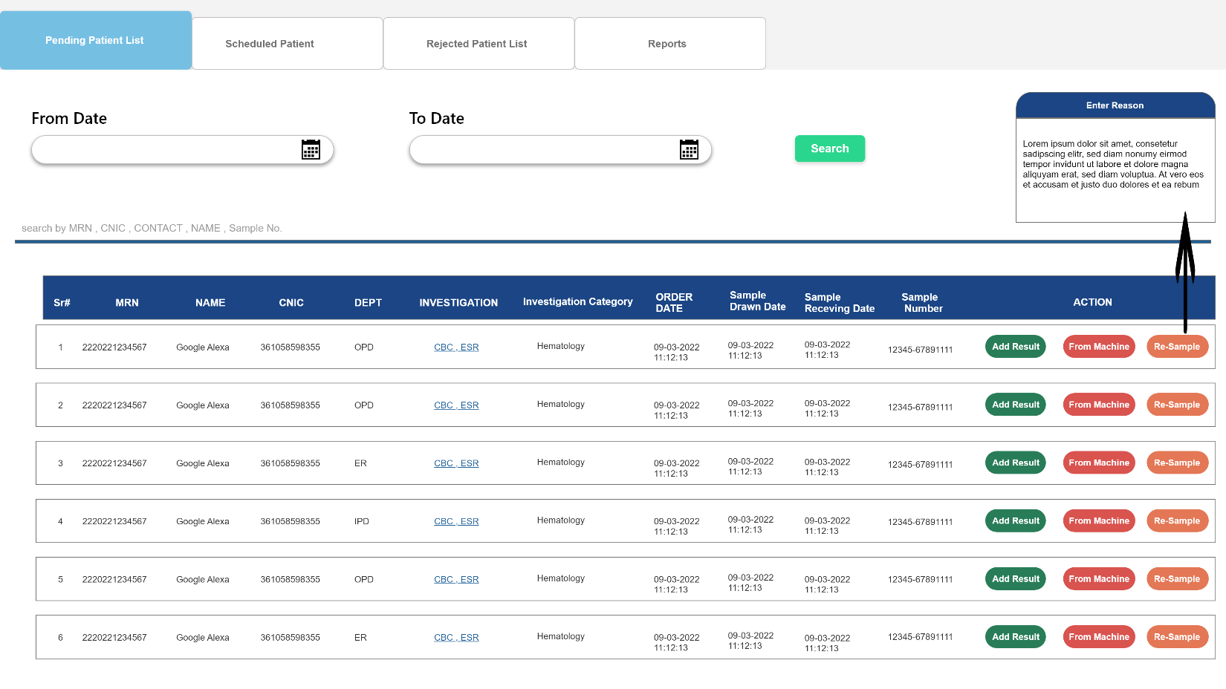**Add Result Button**

- Add Result

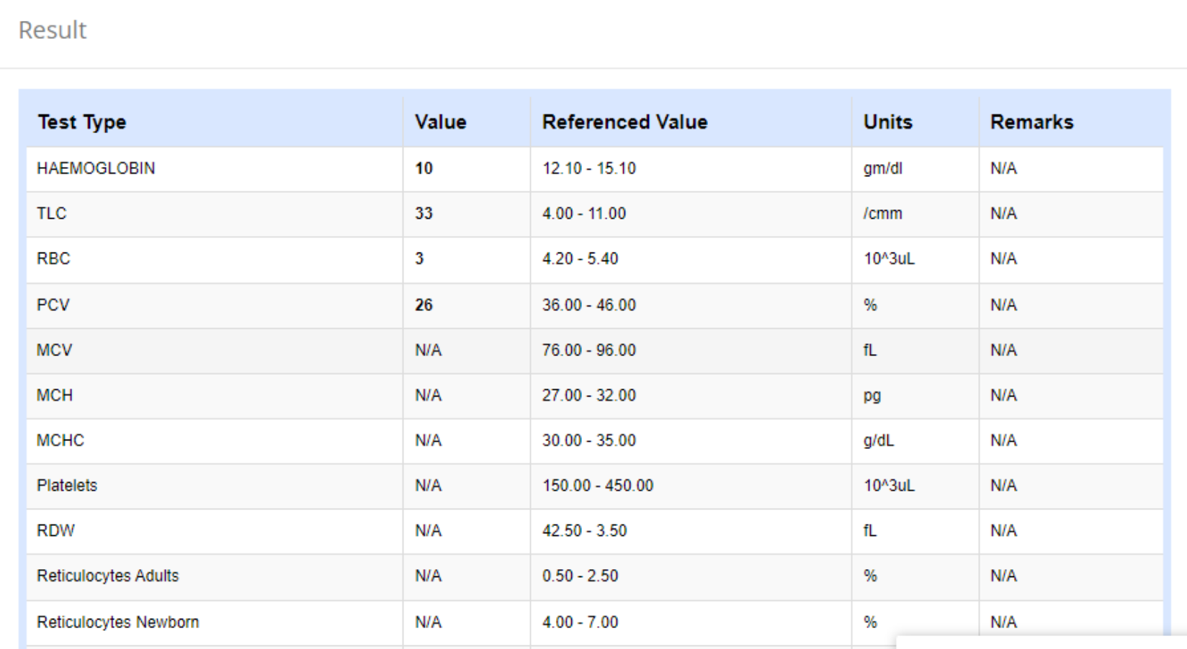

### **Investigation Performed:**

On this page, User can view patients whose result has added by department and pending for verification

**Event Specification:**

User will click on **- Lab Department Scheduled Patient** to view whose result has added by lab department

**Usecase Steps:**

By default **Current Date** filter will active

1. User can select **From Date** and **To Date** filters to view specific dates patients
2. User will click **Search** button after selecting specific dates , it will filter out Pending Patient List of that day if available , otherwise banners a message **“No data found”**
3. User can search patient by following with Like Query

* **MRN , Name , CNIC , Contact , Sample No.**

1. User will have list of patient with following information Columns

* **Serial No , MRN , Name , CNIC, Department , Investigation , Order Date ,Sample Drawn Date , Sample No, Investigation Category , Sample Receiving Date**
* **Status : Verification Pending button**

1. User will click **Add Result** button to add performed result of specified investigations manually

**Section Header**

|  |  |  |  |  |  |
| --- | --- | --- | --- | --- | --- |
| Sr. No. | Field Name | Type | Values | Detail | Validation |
|  | From Date | Date | System Calendar | User can select a day in this field | Mandatory |
|  | To Date | Date | System Calendar | User can select a day in this field | Mandatory |
|  | Search | Button | Search | To search all selected information | Mandatory |
|  | Like Search Filter | Text field | String | This search bar will have like query to filter out alphanumeric user inputs in this field | Mandatory |

* **Note: Investigations marked as blue means clicking this will show dependencies/ specifics in detailed pop-up preview**

**Section Body (Columned List)**

|  |  |  |  |  |  |
| --- | --- | --- | --- | --- | --- |
| Sr. No. | Label Name | Type | Values | Detail | Validation |
|  | Sr# | Read-Only | System generated numeric values | Lists patient in ascending order as per serial number | Mandatory |
|  | MRN | Read-Only |  | Retrieve values from database saved against it | Mandatory |
|  | Name | Read-Only |  | Retrieve values from database saved against it | Mandatory |
|  | CNIC | Read-Only |  | Retrieve values from database saved against it | Mandatory |
|  | Department | Read-Only |  | Retrieve values from database saved against it | Mandatory |
|  | Investigation | Read-Only |  | Retrieve values from database saved against it | Mandatory |
|  | Order Date | Read-Only |  | Retrieve values from database saved against it | Mandatory |
|  | Sample Drawn Date | Read-Only |  | Retrieve values from database saved against it | Mandatory |
|  | Sample Receiving Date | Read-Only |  | Retrieve values from database saved against it | Mandatory |
|  | Sample No. | Read-Only |  | Retrieve values from database saved against it | Mandatory |
|  | Status | Button | Pending Verification | This button will display the status of patient pending for result verification | Mandatory |
|  | Status | Button | Icon | User will click this button to view result | Mandatory |

- Lab Department Scheduled Patient

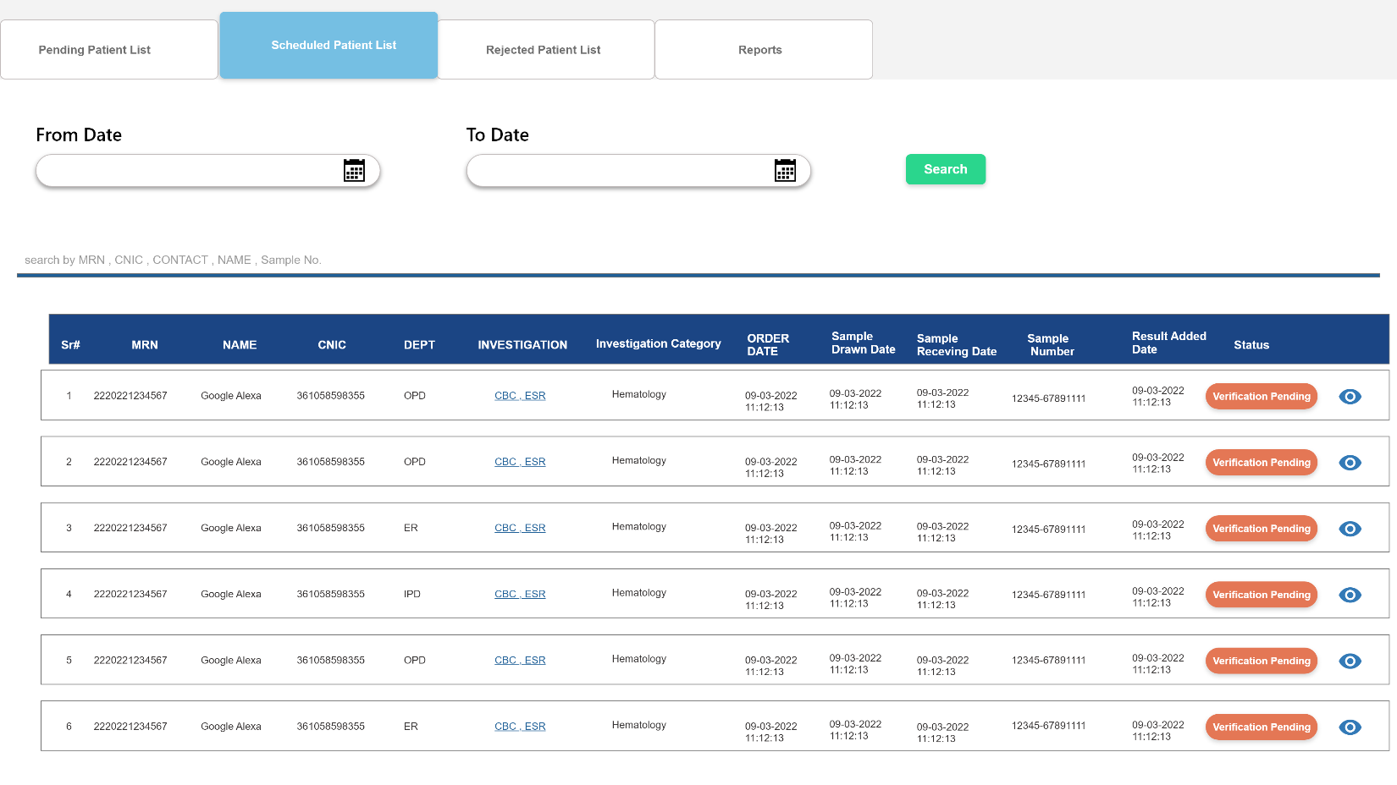

#### **Add Result**

**Event Specification:**

User will click on **- Add Result** add result manually or from Machine

**Usecase Steps:**

1. User will click this **Add Button** to add results and this Add result preview will pop up
2. **This preview will have User Information Header to avoid any ambiguities**
3. System will retrieve **Parameters Name in Specifics Field**
4. System will retrieve **Unit of Parameters** in this field
5. User can enter **Symbols** in this field
6. User will enter **Result** in this field
7. System will parameters **Normal Ranges** in this field
8. Machine integrated Results will retrieved in **Machine Results**
9. User can enter **Remarks** in this field

- Add Result

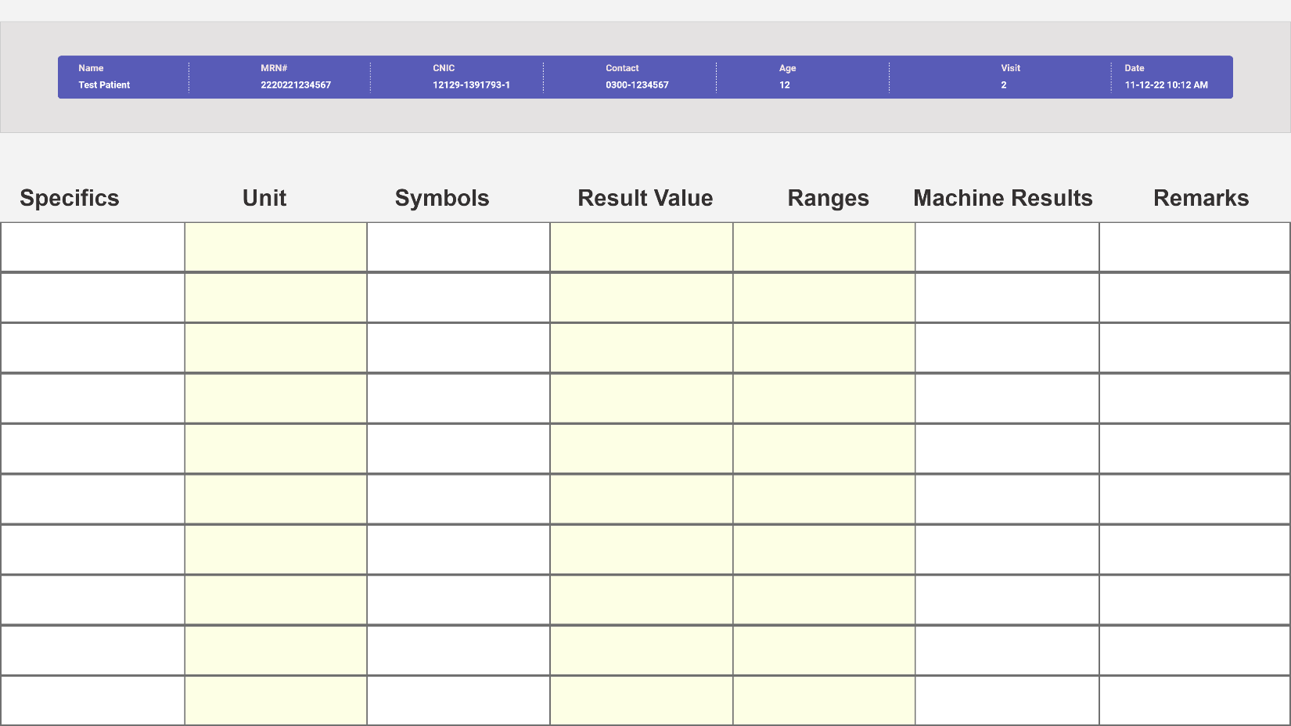

**Section Header (User Demographic Info)**

|  |  |  |  |  |  |
| --- | --- | --- | --- | --- | --- |
| Sr. No. | Field Name | Type | Values | Detail | Validation |
|  | Name | Read-Only |  | Retrieve values from database saved against it | Mandatory |
|  | MRN | Read-Only |  | Retrieve values from database saved against it | Mandatory |
|  | CNIC | Read-Only |  | Retrieve values from database saved against it | Mandatory |
|  | Contact | Read-Only |  | Retrieve values from database saved against it | Mandatory |
|  | Age | Read-Only |  | Retrieve values from database saved against it | Mandatory |
|  | Visit | Read-Only |  | Retrieve values from database saved against it | Mandatory |
|  | Date | Read-Only |  | Retrieve values from database saved against it | Mandatory |

**Section Results**

|  |  |  |  |  |  |
| --- | --- | --- | --- | --- | --- |
| Sr. No. | Field Name | Type | Values | Detail | Validation |
|  | Specifics /Parameters | Read-Only |  | Retrieve values from database saved against it | Mandatory |
|  | Unit | Read-Only |  | Retrieve values from database saved against it | Mandatory |
|  | Symbols | Read-Only |  |  | Mandatory |
|  | Result Value | Numeric | 10 Digit | User can enter up to 10 digits in this field | Mandatory |
|  | Normal Ranges | Read-Only |  | Retrieve values from database saved against it | Mandatory |
|  | Machine Results | Read-Only |  | Retrieve values from Machine incase if integrated machines | Mandatory |
|  | Remarks | Text Area |  | User can enter 100 Character in this text area | Mandatory |
|  | Save | Button | Save | To save above mentioned information in database | Mandatory |

### **Verify Results:**

On this page, User can view patients whose result has added by department and pending for verification

**Event Specification:**

User will click on **- Lab Incharge Verification** to view whose result has added by lab department

**Usecase Steps:**

By default **Current Date** filter will active

1. User can select **From Date** and **To Date** filters to view specific dates patients
2. User will click **Search** button after selecting specific dates , it will filter out Pending Patient List of that day if available , otherwise banners a message **“No data found”**
3. User can search patient by following with Like Query

* **MRN , Name , CNIC , Contact , Sample No.**

1. User will have list of patient with following information Columns

* **Serial No , MRN , Name , CNIC, Department , Investigation , Order Date ,Sample Drawn Date , Sample No, Investigation Category , Sample Receiving Date**
* **Status : Verify**
* **Status : Verified button and View Icon**

1. User will enter Remarks in this text area then
2. User will click **Verify** buttonto verify the result and preview of results will appear having buttons **Verify & Save , Re-Perform**

**Section Header**

|  |  |  |  |  |  |
| --- | --- | --- | --- | --- | --- |
| Sr. No. | Field Name | Type | Values | Detail | Validation |
|  | From Date | Date | System Calendar | User can select a day in this field | Mandatory |
|  | To Date | Date | System Calendar | User can select a day in this field | Mandatory |
|  | Search | Button | Search | To search all selected information | Mandatory |
|  | Like Search Filter | Text field | String | This search bar will have like query to filter out alphanumeric user inputs in this field | Mandatory |

* **Note: Investigations marked as blue means clicking this will show dependencies/ specifics in detailed pop-up preview**

**Section Body (Columned List)**

|  |  |  |  |  |  |
| --- | --- | --- | --- | --- | --- |
| Sr. No. | Label Name | Type | Values | Detail | Validation |
|  | Sr# | Read-Only | System generated numeric values | Lists patient in ascending order as per serial number | Mandatory |
|  | MRN | Read-Only |  | Retrieve values from database saved against it | Mandatory |
|  | Name | Read-Only |  | Retrieve values from database saved against it | Mandatory |
|  | CNIC | Read-Only |  | Retrieve values from database saved against it | Mandatory |
|  | Department | Read-Only |  | Retrieve values from database saved against it | Mandatory |
|  | Investigation | Read-Only |  | Retrieve values from database saved against it | Mandatory |
|  | Order Date | Read-Only |  | Retrieve values from database saved against it | Mandatory |
|  | Sample Drawn Date | Read-Only |  | Retrieve values from database saved against it | Mandatory |
|  | Sample Receiving Date | Read-Only |  | Retrieve values from database saved against it | Mandatory |
|  | Sample No. | Read-Only |  | Retrieve values from database saved against it | Mandatory |
|  | Result Added Date | Read-Only |  | Retrieve values from database saved against it | Mandatory |
|  | Status | Button | Verify | This button will display preview of result entered with buttons  **Verify and Save**  **Re-Perform : this will send results back to lab department to re-perform** | Mandatory |
|  | Status | Button | Verified | It will display that result has been verified and available for preview patient result will move to Report Page for print |  |
|  | Consultant Remarks | Text Area | 1500 Character | User can enter 1500 Alphabets in this | Mandatory |
|  | Doctor Remarks |  |  |  | Mandatory |
|  | Technologist Remarks | Text Area | 1500 Character | User can enter 1500 Alphabets in this | Mandatory |
|  | Verify & Save | Button |  | **To Verify and Save Result** | Mandatory |
|  | Re-Sample | Button |  | **To order re-sampling of patient and patient will land on Sample Collection Page** | Mandatory |
|  | Re-Perform | Button |  | **Verify and Save**  **Re-Perform : this will send results back to lab department to re-perform** | Mandatory |

- Lab Incharge Verification

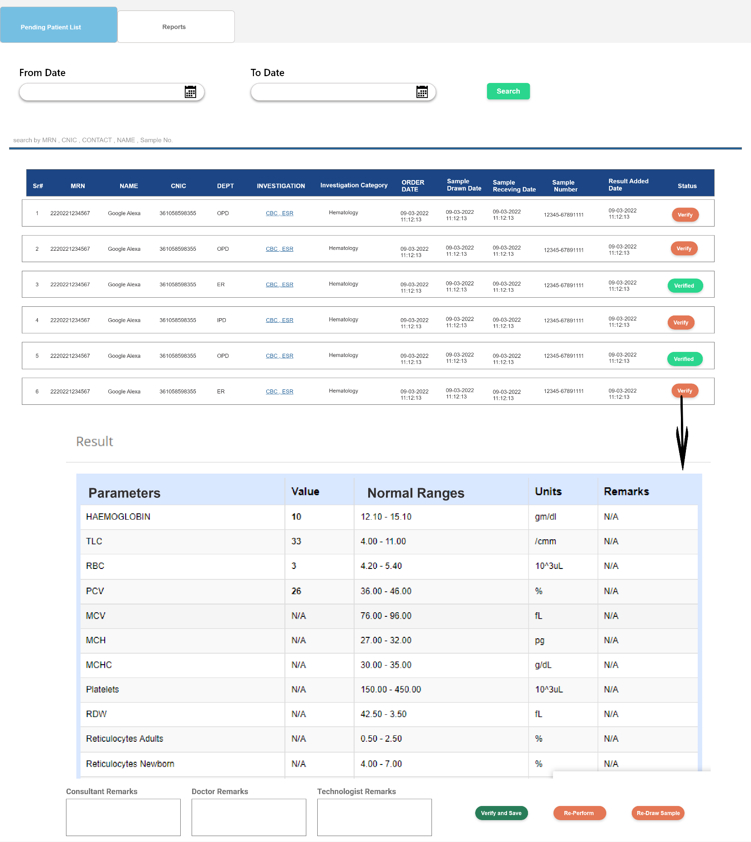

### **Reports:**

User can view report on this page in printable format

